How to make the Walk to Transit buffers

The model assumes that people will walk .4 miles to get to and from transit. An important step in determining transit ridership is then to determine how many people are within this .4 mile buffer of transit stops.

- Use this process whenever you need to make significant changes to a buffer field in the "walkbuffer.dbf" file.
- If you only need to adjust a single route or two, you can just estimate the share of affected zones that are within 0.4 miles of transit.

Converting Cube LIN files into Shape files

- Ensure that all transit line files are updated in Cube.

- Open "_CreateTransitDBF.s" in an editor
- Update the location of the Master Network and the relevant lane field.
- Confirm that the names of the transit .lin files are the same as the ones in your Lin directory

- Save and run "_CreateTransitDBF.s"
- This script will create the following files and store them in the “CreateTransitDBF” directory:
  - 1_All_Transit.dbf
  - 2_LocalBus.dbf
  - 3_BRT_Exp_LRT_CRT.dbf
  - 0_Scenario.net"

- Open 0_Scenario.net, and load 2_LocalBus.dbf into the transit layer.

- Visually inspect the file and if the and if it looks correct, go to “File/Export” and select "Transit shape file". Browse to "CreateTransitDBF\EOP3_TransitShp" and overwrite "LocalBus.shp".

- Now load 3_BRT_Exp_LRT_CRT.dbf onto the 0_Scenario.net network.

- Go to “File/Export”, but this time select "Transit stops shapefile" as the type. Save the file to the same location as the 2_LocalBus shapefile and overwrite the file named "Stops.shp"

Create a 4/10 mile buffer around local bus routes and premium transit stops

- Once these 2 shapefiles are updated, open the “_CleanWalkBuffer.mxd” project and double click to open ArcView. It should automatically load "stops.shp" and "localbus.shp" which you just made. It also has links for the TAZ file, and placeholders for the buffer files you're about to make.

NOTE: If there is an error message next to the shapefile box in the legend, you may have to repair the data source. Right mouse click on the shapefile name and go to “Data\Repair Data Source”.

- Go to "\BufferIntermediateFiles\" and delete every file that is in here, the process will be re-creating these files and Arcview won't let you overwrite.

- Open the "ArcToolbox". Right mouse click on ArcToolBox title at the top of the list and choose “Add Toolbox”. Browse to 4_Transit and add the ”Transit Walk Buffer” toolbox.

- Double click on the “Run Walk Buffer Model”. A dialogue box similar to the one below will pop up.

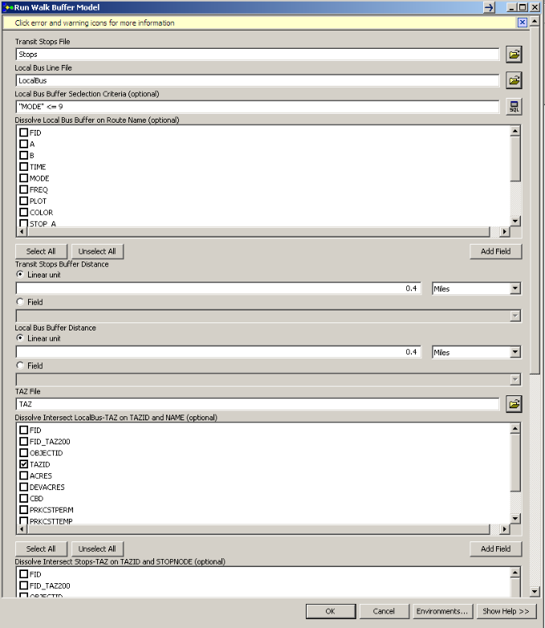

- Click ‘OK’. Depending on your processor, the entire process takes about 3-5 minutes.

- Once you have created a new WalkBuffer.dbf with the WALKPCT field updated, you are done.

- Close the ArcView Project _CleanWalkBuffer.mxd. DO NOT SAVE.

Process Description

Since local bus routes stop frequently, this process assumes the entire line is accessible and therefore creates a buffer around the entire line itself. Premium transit, including express bus, light rail, commuter rail and BRT only provide access at specific stops, so the process only creates buffers around the stops on these lines.

Prior to Version 6.1, WALKPCT was simply the merge of all transit buffers, and the share of the zone that was covered by the merge. So if a TAZ was outlined by 4 routes, and the buffer of all routes covered the whole TAZ, then the TAZ would be “100% walk accessible”.

By looking at each route and stop individually, we may find that only 30% of those in a zone have walk access to any given route, even though 100% have access to at least one route. So the new WALKPCT is then 30% instead of 100%. The reason for this change was to avoid implying that every person in a zone has perfect walk access to every route.

Common Arcview Mistakes
- If any records are selected, actions are performed only on selected features. Be sure to “Clear Selection” before these actions.
- Sometimes Arcview won’t allow the process to edit fields, etc. Try saving the project, then closing down Arcview and restarting.

